# Admin Initial set up of time clock for use

Double click

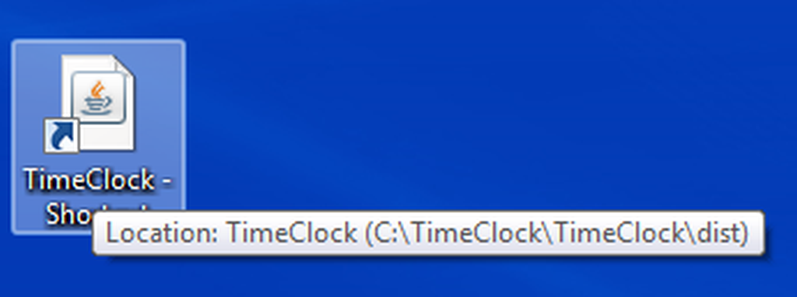

Click to Login

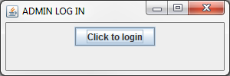

In the user name enter “bob”

In the password enter “secret”

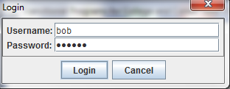

Click login

To set up initial database:

Click class menu and CreateDB

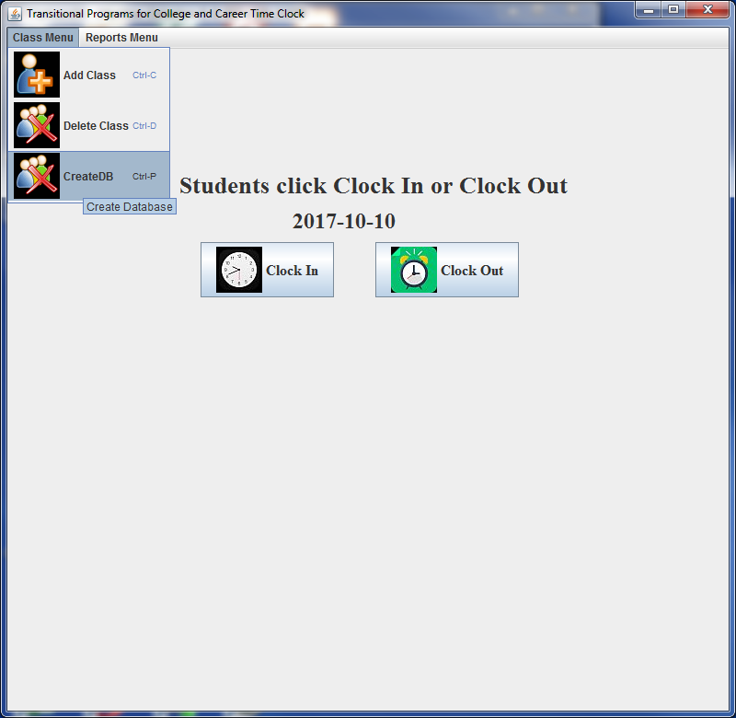

This takes a little while to do and the program may appear to be doing nothing. Just wait for it to finish.

# To load classes into the system:

Click Class Menu then Add Class

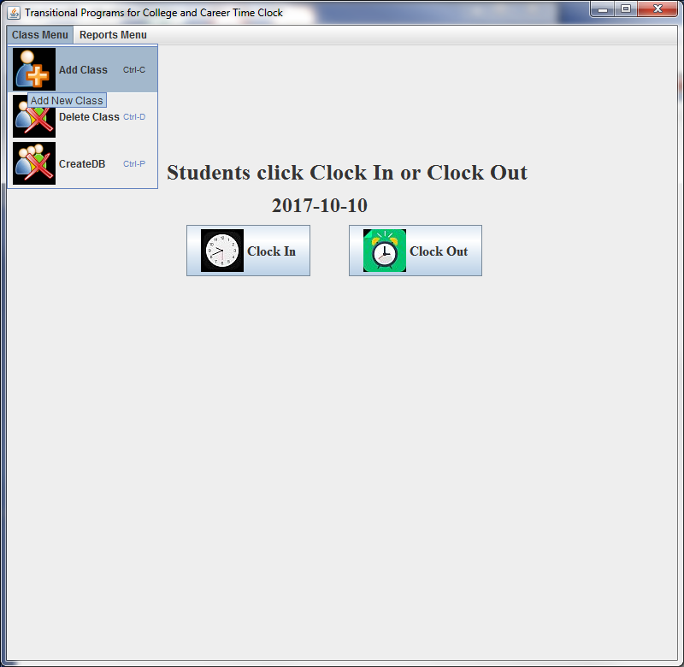

Enter the class name and class contract number and hit submit

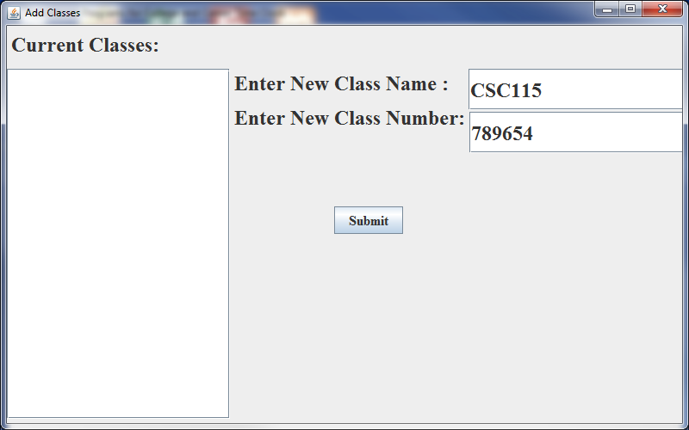

# To delete a class loaded in error

Click Class Menu then delete class

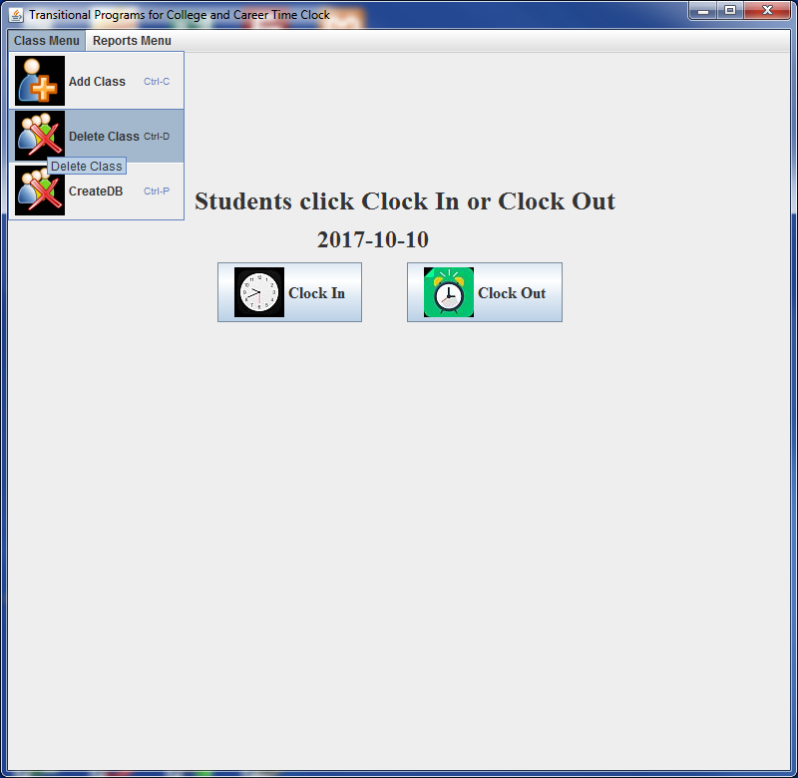

Double click the class name made in error

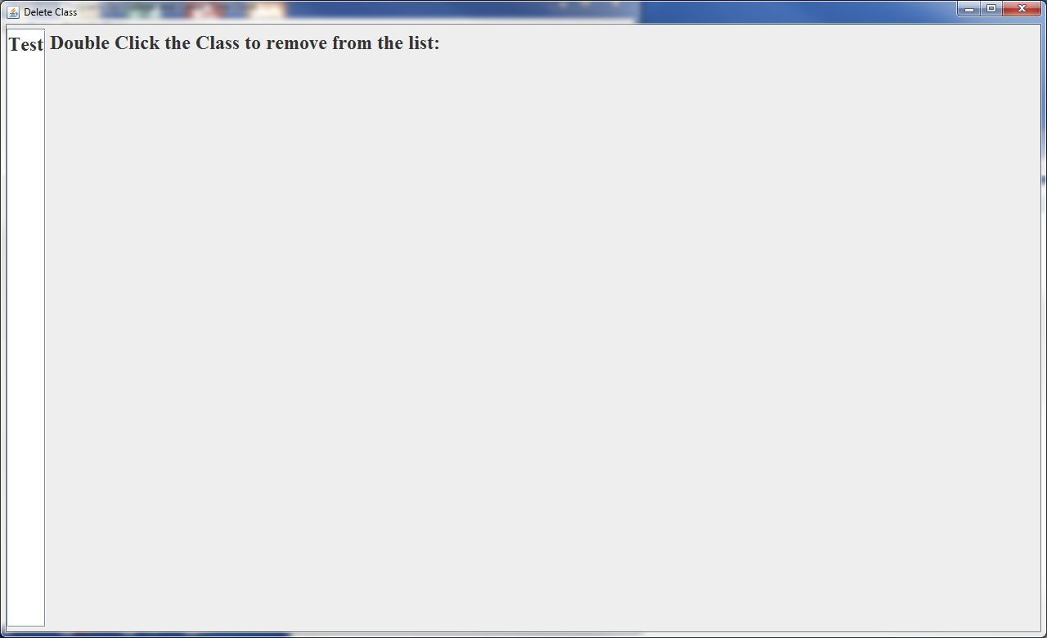

The word deleted will replace the class name until you close the window.

# Reports

To print a report you must have a database created, classes loaded, and at least 1 student has to have been created.

Click Reports menu, and select the report you wish to run.

Drop down’s should populate, if they do not, you either do not have any classes loaded or no students loaded.

The … box is a calendar picker and must be clicked and a date selected before hitting submit.

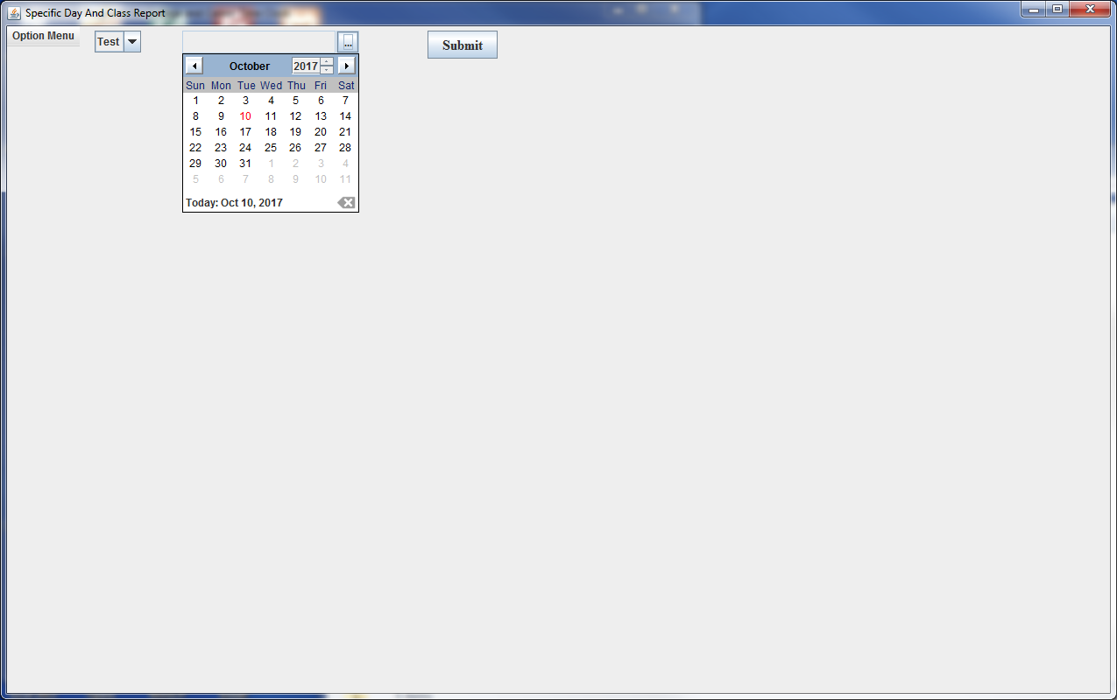

The options menu will give you the option to print the table or some reports offer print the screen. ALL reports will print in both portrait and landscape, but landscape is much easier to read.

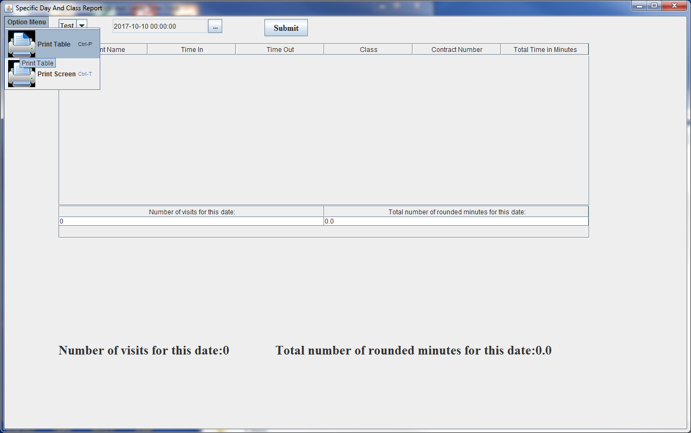

You can ONLY generate one report per report menu click. If you made an error in your selection criteria. Exit the report form and re-open it from the menu.

# Deleting the database

IMPORTANT: Make sure no one is running time clock.

Navigate to wherever you have this running and delete the folder called student_

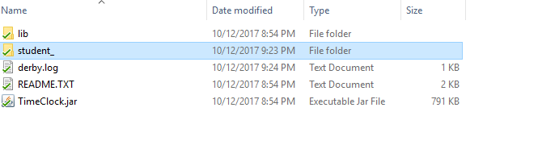

# Back up the database

Copy the student_ folder to another location



# Restoring the database

Copy the backed up database into the folder that TimeClock.jar is being run from delete student_ folder and rename the student-Copy folder to student_

Student Use

# Clock in

Click Clock in button to start

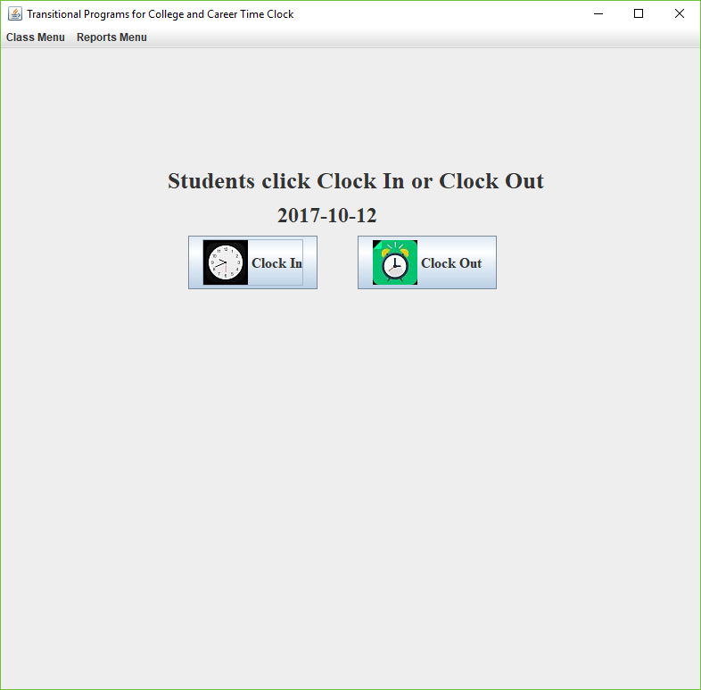

Enter your 6 or 7 digit student ID and press enter

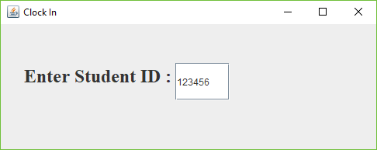

Enter the information in the form and select the class you are here for from the drop down menu

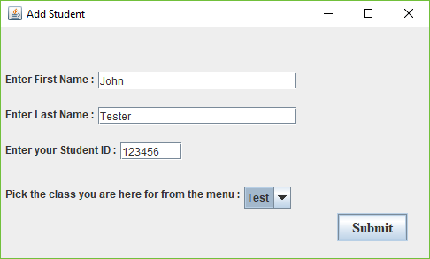

Hit submit

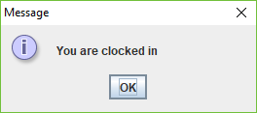

Hit ok

# Clock Out

Click the clock out button



Enter your student ID and press enter

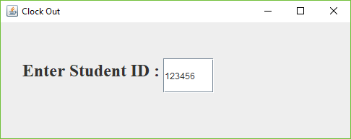

Click ok

